**UBER TRAFFIC ANALYSIS**

**Using Microsoft Power BI**



**By**

**Danish Shaikh**

**TCRIN01R12**

**Contents**

1. Abstract 3
2. Acknowledgment 4
3. Introduction 5
4. Objective 6
5. Model 7
6. Result 8
7. Conclusion 9

References 10

**Abstract**

Under the guidance of our TCR mentors, I have developed a dashboard in which we can see the Uber traffic analysis. Through this analysis we can take action to prevent traffic jams in the city.

This dashboard shows us analytical views on traffic in the city. It gives us broad idea about when, where & why this traffic jams are happening. Using this power bi dashboard we can take action against the traffic jams so we can prevent it.

So, this project is very important because this project solves the everybody life problems of many people.

**Acknowledgement**

I remain immensely obliged to TCR innovation for providing me with the idea of this topic, and for invaluable support in gathering resources for me either by way of information or computer also guidance and supervision which made this project successful.

**Introduction**

“Uber traffic analysis using Microsoft Power BI" this my project. In which I have given the excel data of Uber of the Bengaluru city. So, using this data I have to develop dashboard from this dashboard we can able to see the travel time of the uber cars.

Using this data we can do many things. We know that today traffic jams in the Bengaluru city is common. So if we want prevent this traffic jams then we can take help of this Power BI dashboard. By taking help of the dashboard we can see the when and on what time uber cars travel most so we can take actions according to it.

So, this my project in which I will doing Uber traffic analysis using Microsoft Power BI

**Objective**

* My main objective of this project is traffic planning using Power BI dashboard

**Model**

In my dashboard I have used various graphs and pie charts and tables. So, anyone can easily understand it.

1. Pie chart : I have used this visual to get idea to viewer about morning, midday & evening range time per year.
2. Line chart : I have used to show average travel time on the basis on per year.
3. Filled map : I have used this visual to show where are this uber cars are travelling.
4. Bar chart : This visual shows us AM & PM travel time per year.

**Result**

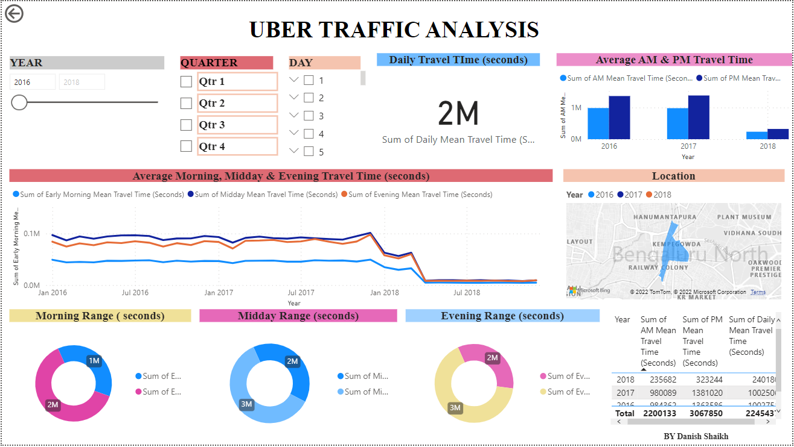

**Conclusion**

Using the Microsoft Power BI I have done the analysis of the uber cars. Now using this dashboard we can take action against traffic jams. Also traffic planning we can do effectively.

**References**

* <https://www.wikipedia.com>
* <https://www.youtube.com>
* <https://www.uber.com>